CREATING A MINIKUBE SERVICE TO HANDLE CONTAINERS



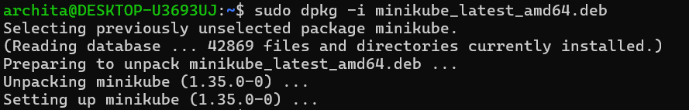

STARTING MINIKUBE:

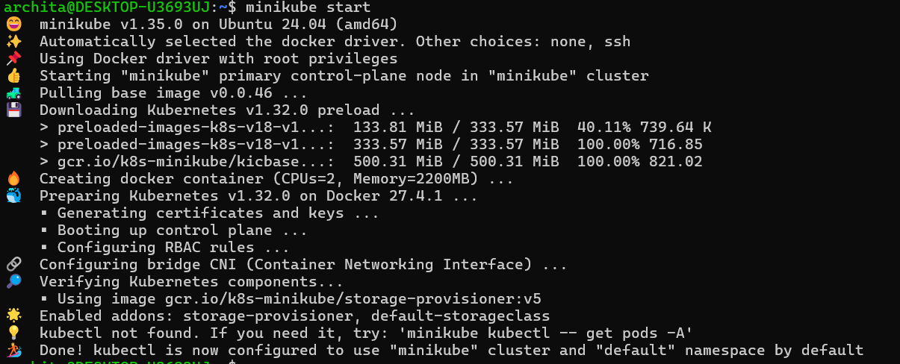

INSTALLING KUBECTL:

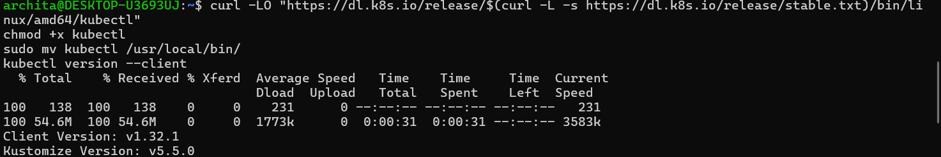

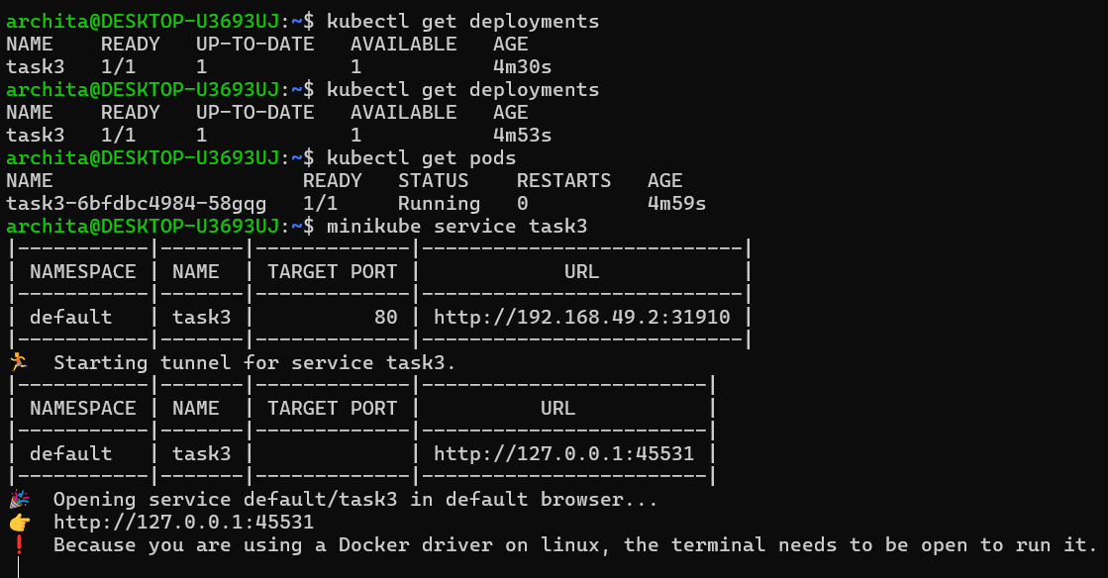

FINAL OUTPUT:

